NAMA : ILPAN

NPM : 41155050210046

KELAS : A-2

MATA KULIAH : MACHINE LEARNING

Tugas

1.

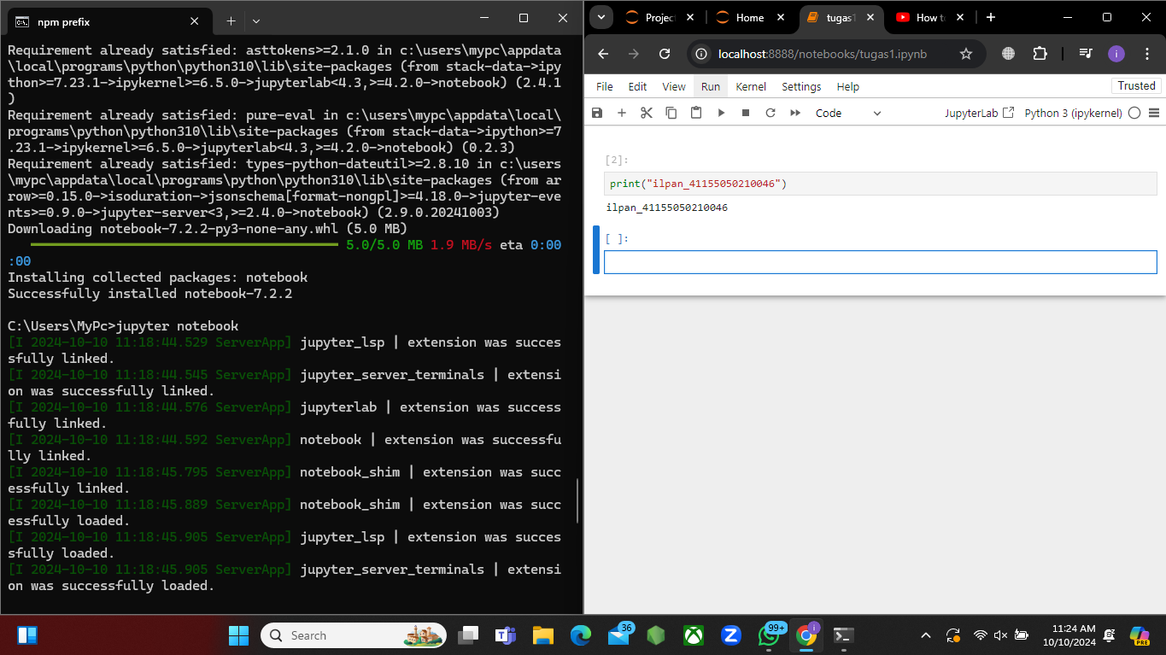Instalasi Jupyter

Liblary

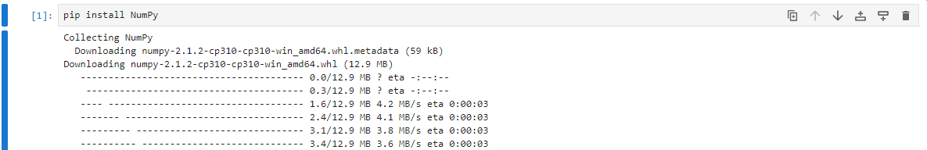NumPy

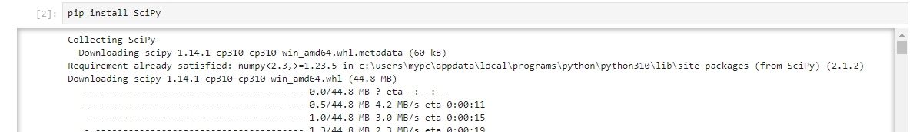SciPy

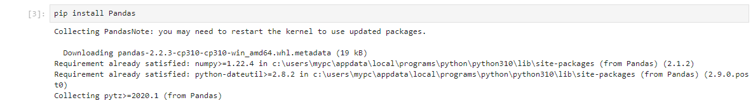Pandas

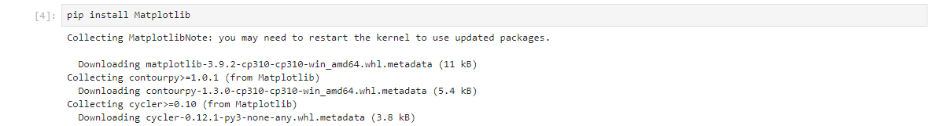Matplotlib

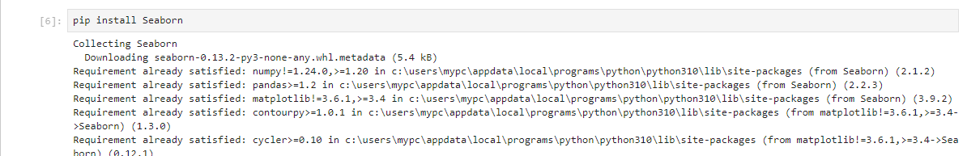Seaborn

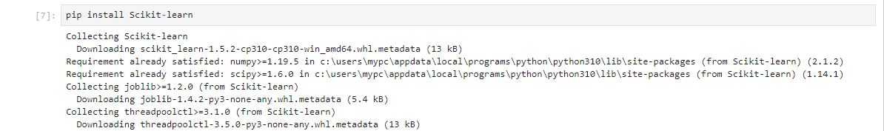Scikit -learn

2.

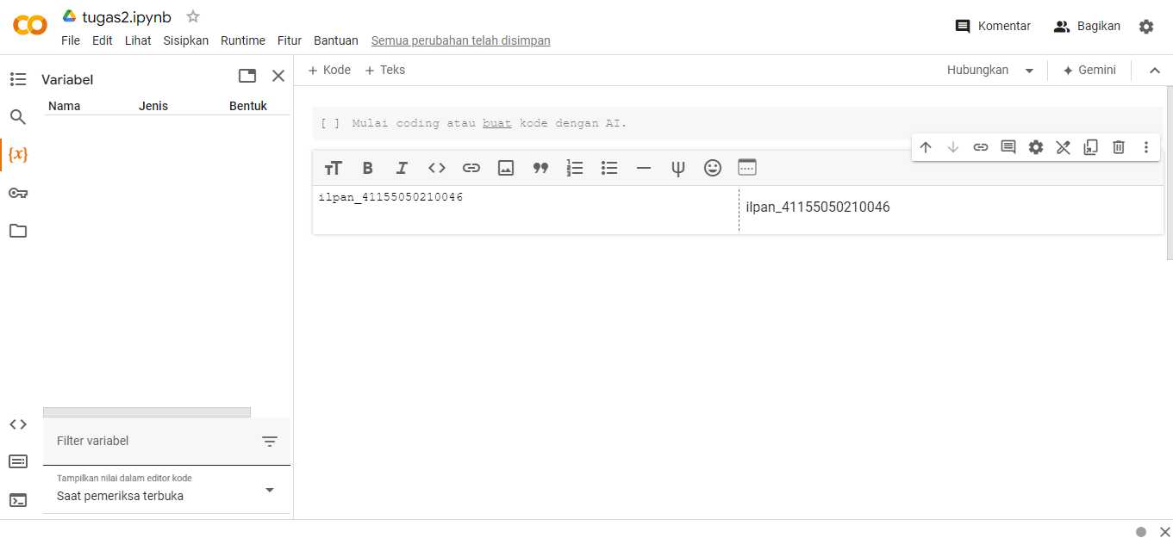Register Google Collab

3.

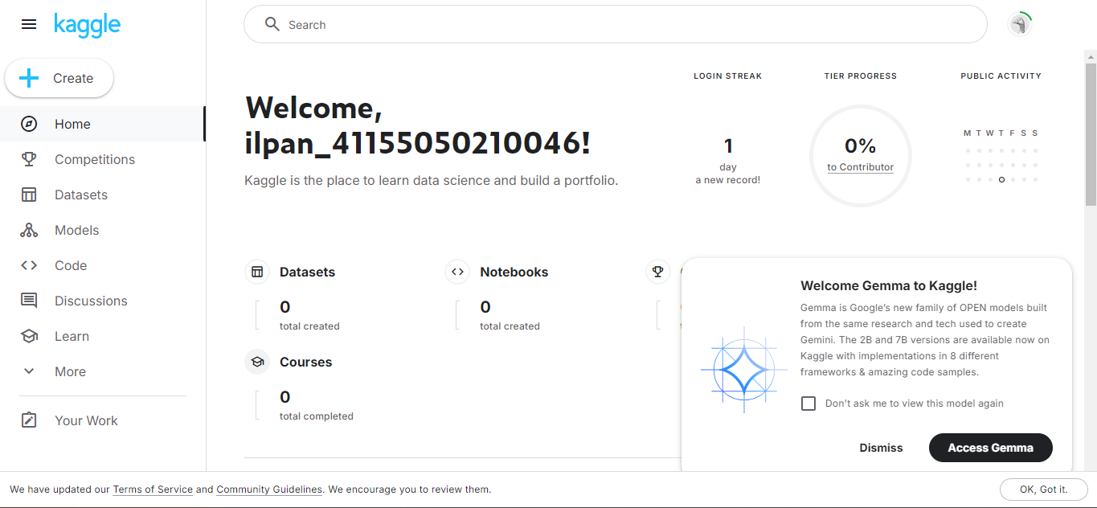Register Kaggle

4.

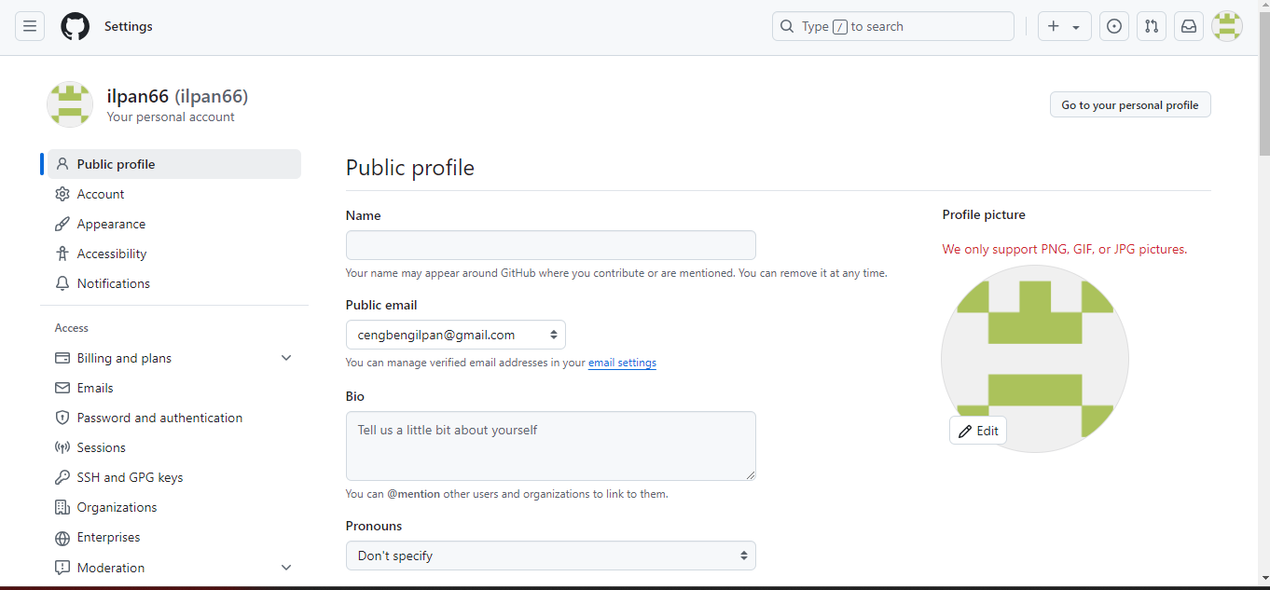Register GitHub

5.

Load sample Dataset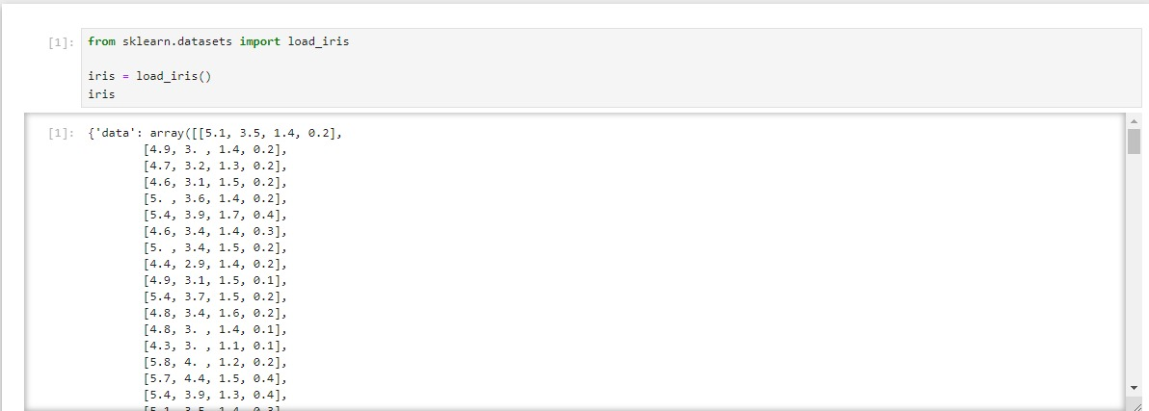

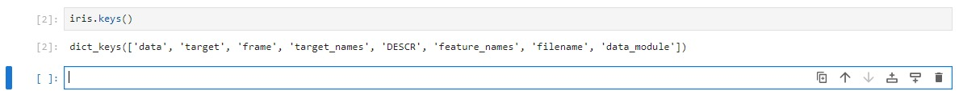

Metadata | Deskripsi dari sample dataset

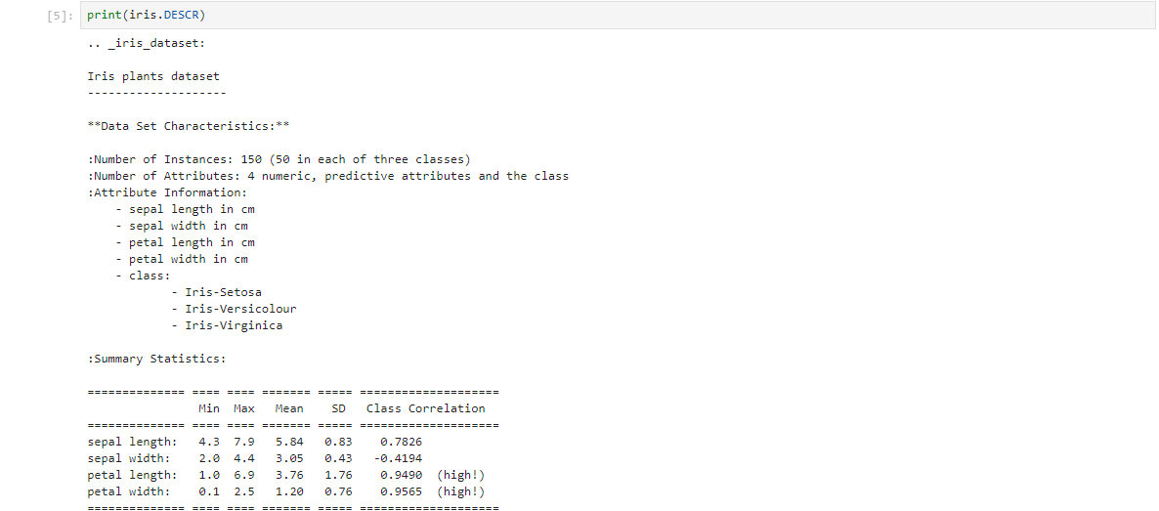

Explanatory & Response Variables | Features & Target

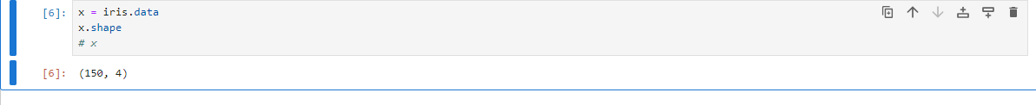Explanatory Variables (Features)

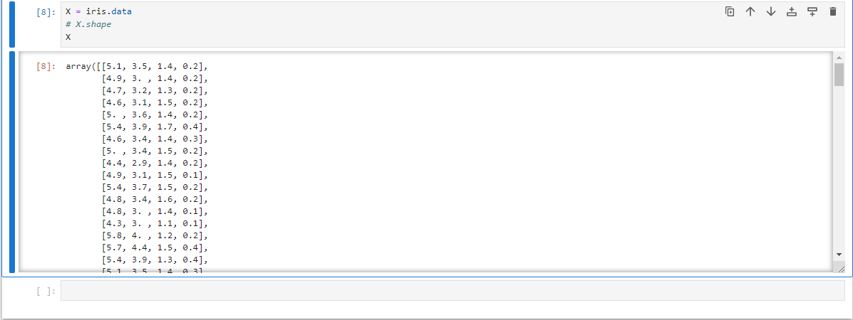

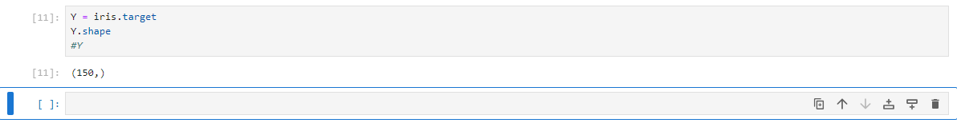Response Variables (Target)

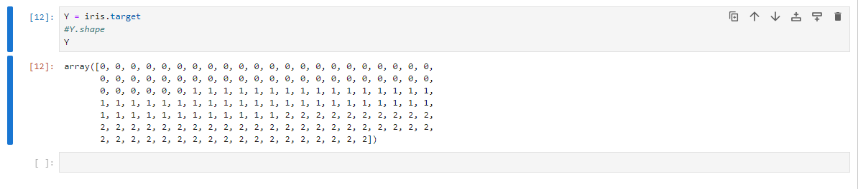

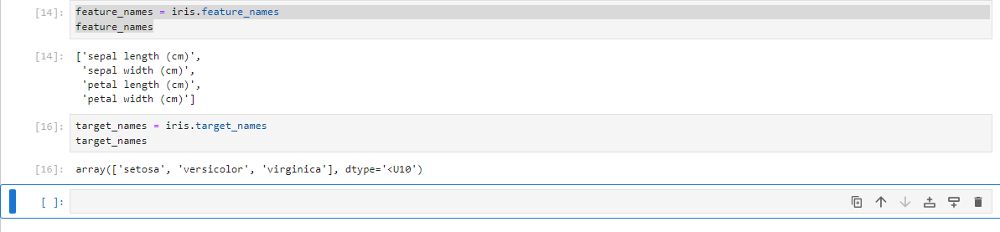Feature & Target Names

Visualisasi Data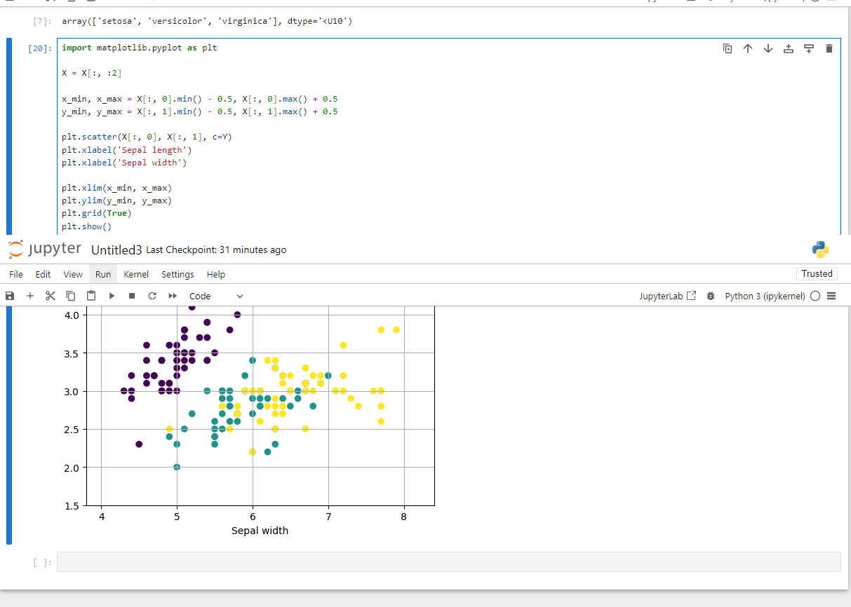

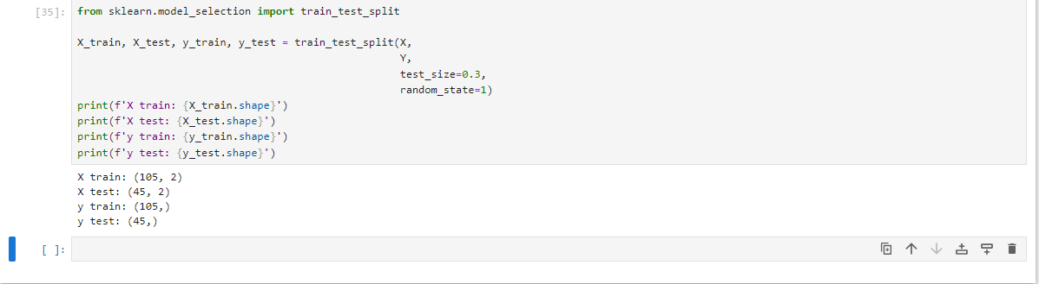Training Set & Testing Set

Load sample dataset sebagai Pandas Data Frame

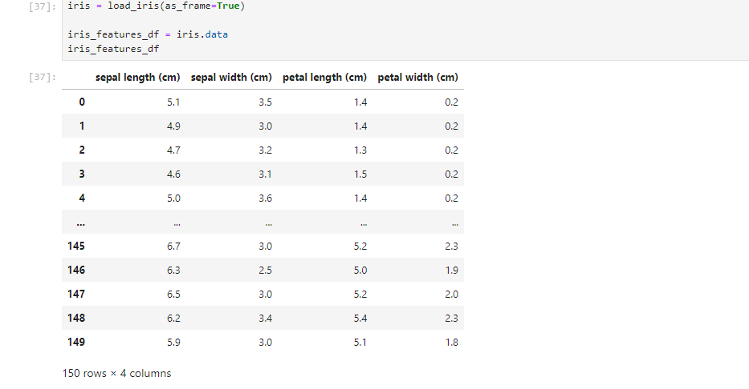

6.

Persiapan dataset | Loading & splitting dataset

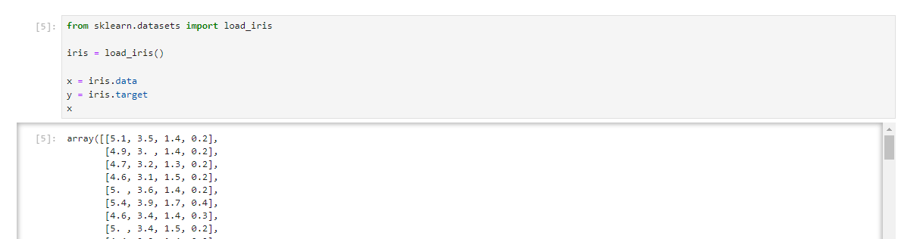Load sample dataset : Iris Dataset

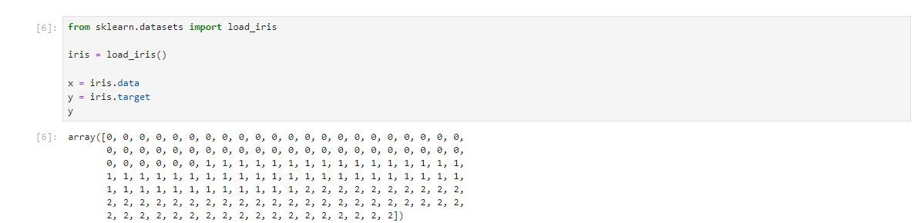

Splitting Dataset : Training & Testing Set

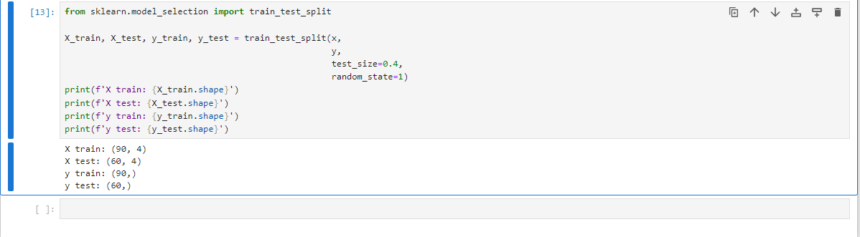

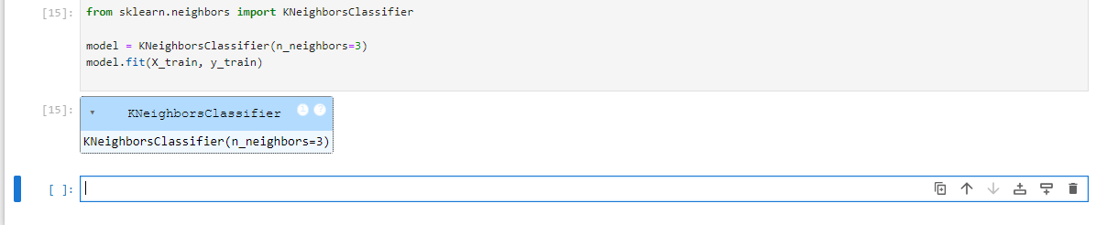Training model Machine Learning

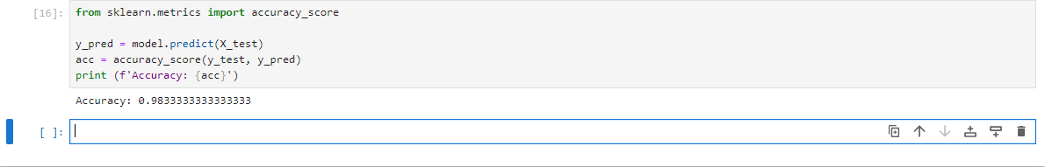Evaluasi model Machine Learning

Pemanfaatan trained model machine learning

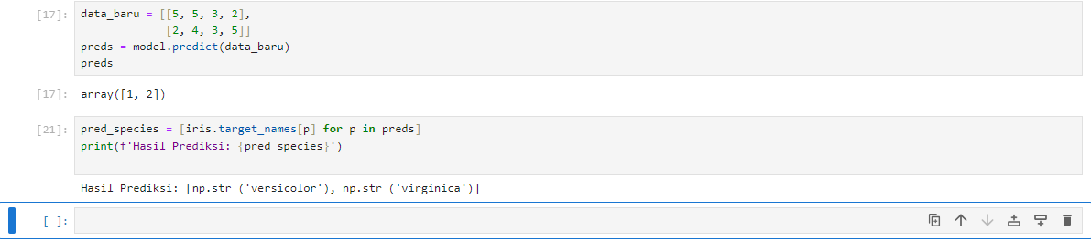

Deploy model Machine Learning | Dumping dan Loading model Machine Learning

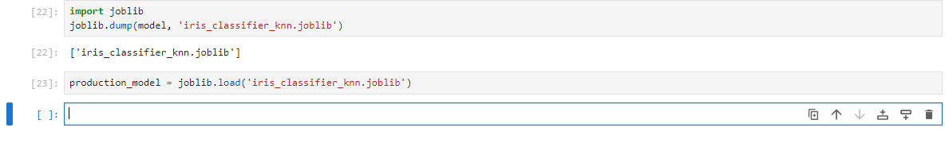

7.

Persiapan sample dataset

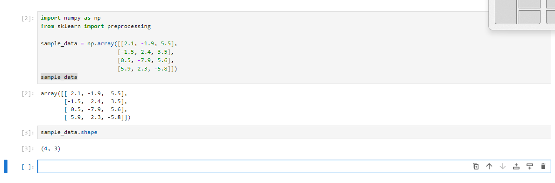

Teknik data preprocessing 1: binarization

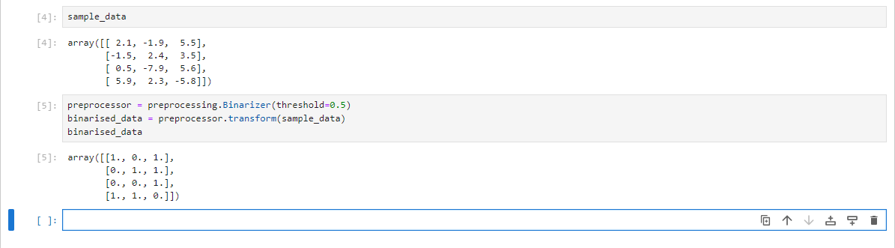

Teknik data preprocessing 2: scaling

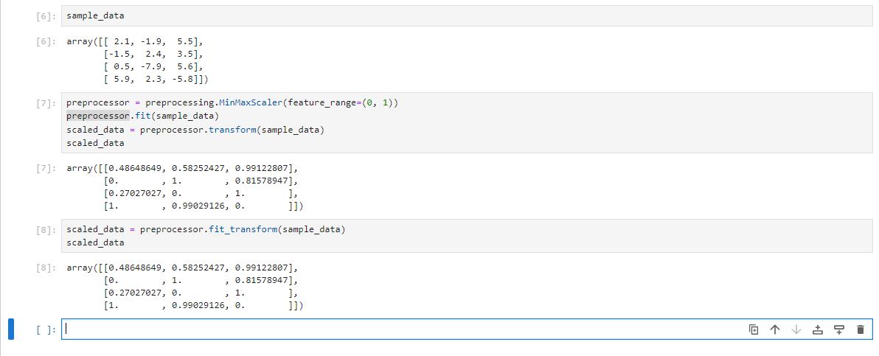

Teknik data preprocessing 3: normalization

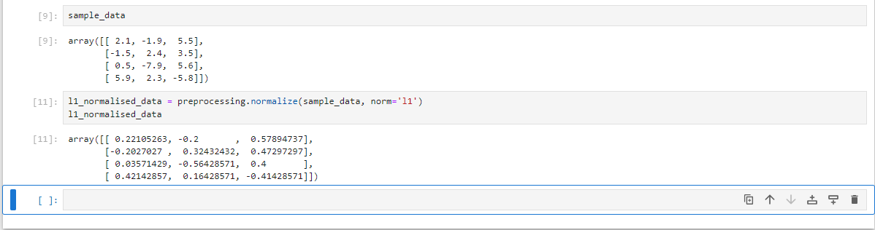Least Absolute Deviations

Least Squeres

